1. Introduction

This is simple Documentation for getting started with C# using Microsoft Visual Studio in windows. Document contains step to step guide for creating Helloworld application in C# using Microsoft Visual Studio.

We will be using Microsoft Visual Studio 2019 Community edition.

1. Steps
2. Open Microsoft Visual Studio,
   1. From Widows Search Bar.
   2. From following path “C:\Program Files (x86)\Microsoft Visual Studio\2019\Community\Common7\IDE\devenv.exe”
3. Now You will See something like that

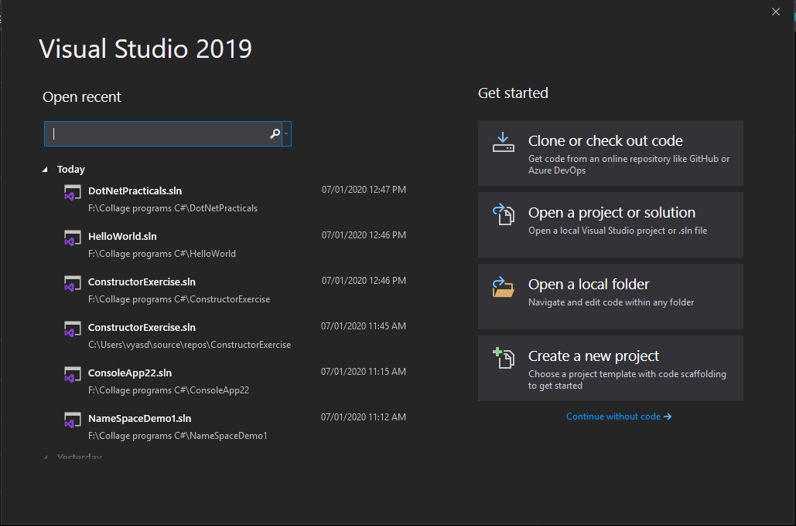

1. Select Create New Project.( You will window as shown below)

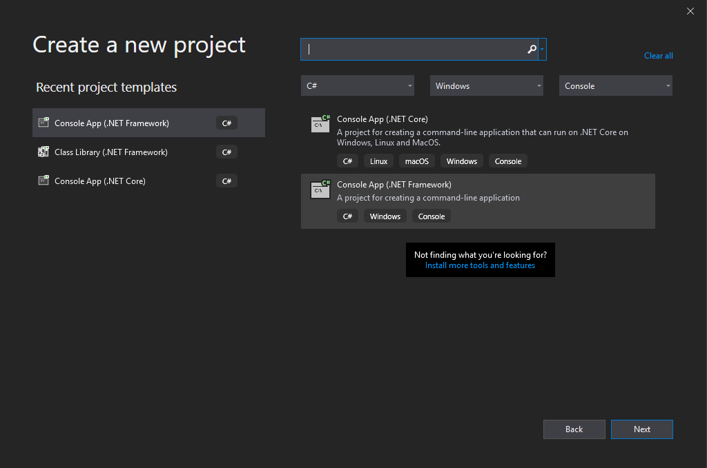

Click Next and Enter Project Name and Solution name(optional).

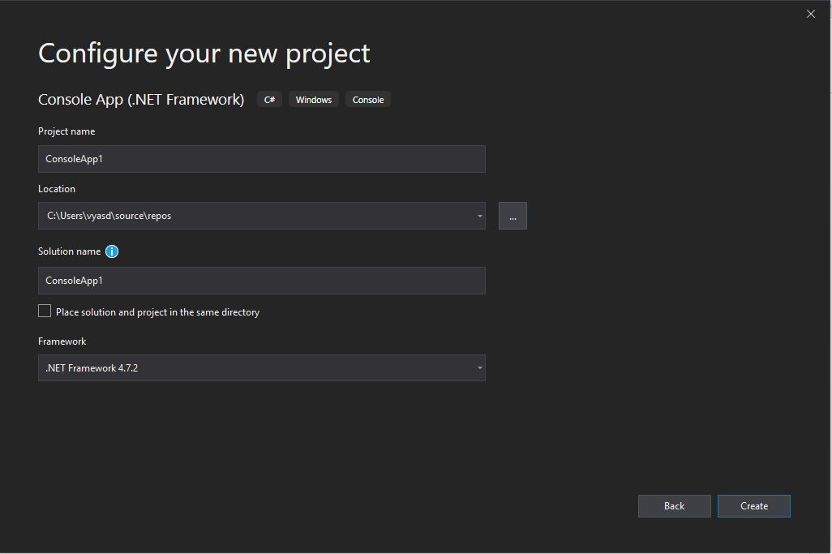

And click Create.

1. Then After You will get Window Like this

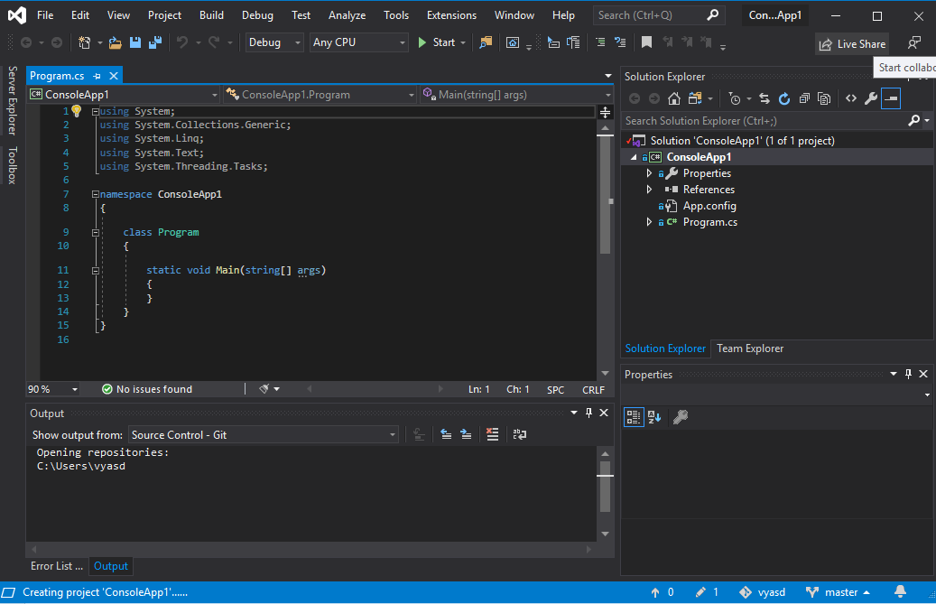

1. Now in main method ( just like C ) write one line to Print hello world as follow.

Console.WriteLine(“Hello World”);

As we used to write printf(“Hello World\n”) in C, here Console.WriteLine() is used.

Note That

* printf(“\n”); = Console.WriteLine();
* printf(); = Console.Write();

Click on button look like Play button in toolbar and click it. You will See Console Window.

Here, after performing this You’ll notice that Console Screen appears only for a moment so to fix that we use

Console.Read(); { just like we used getch() in C }

1. So there you go, your Final Program would look like …

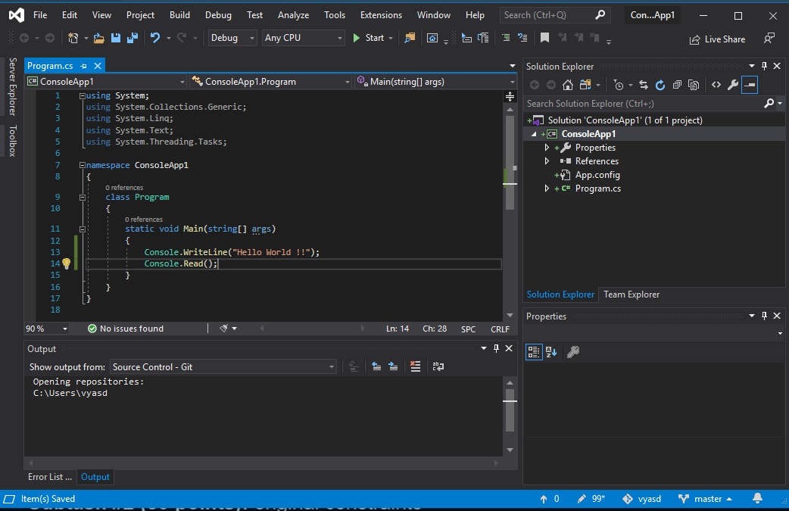

Click on button look like Play button in toolbar and click it. You will See Console Window.